E-Commerce Sales Performance Analysis

Prepared By: Harsh Patidar
Date: 11 June 2026

Objective
The objective is to identify patterns in sales performance, customer behavior, and regional delivery times to drive business growth and operational efficiency.

Dataset Description
The analysis utilizes the Olist dataset, comprising 99,441 orders across a multi-table structure. After merging relevant tables (Orders, Items, Products, Customers, Payments, Reviews, Sellers, Geolocation), the final dataset consists of 119,143 records.

Data Cleaning Summary
- Translating product category names to English.
- Dropping duplicate records to ensure data integrity.
- Fixing data types for timestamps and categorical variables.
- Handling anomalies, such as validating numerical values for prices, freight, and payment data to ensure no negative values exist.

Analysis Findings
- Market Concentration: High sales concentration, with the São Paulo (SP) state representing over 37% of total orders.
- Customer Retention: Low customer retention, with only 3.0% of buyers identified as repeat customers.
- Top Revenue Drivers: Key revenue-generating categories include Health & Beauty, Watches & Gifts, and Bed, Bath & Table.
- Logistics Performance: Average delivery time stands at 12.5 days, highlighting potential bottlenecks.
- Payment Preferences: Credit cards dominate the payment landscape, accounting for over 70% of transactions.

Visualizations
- Figure 1: Monthly Sales Trends
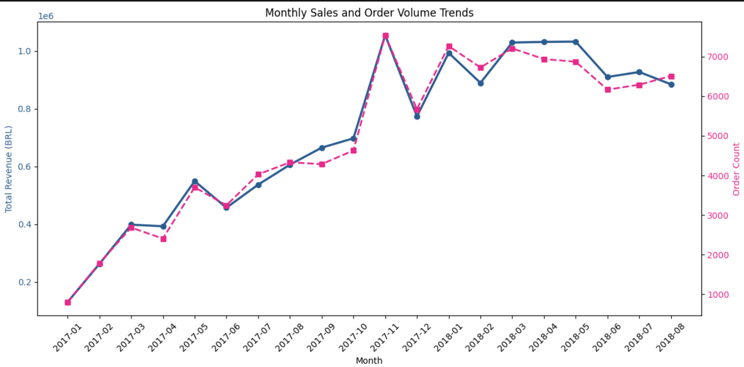

- Figure 2: Top 15 Product Categories by Revenue
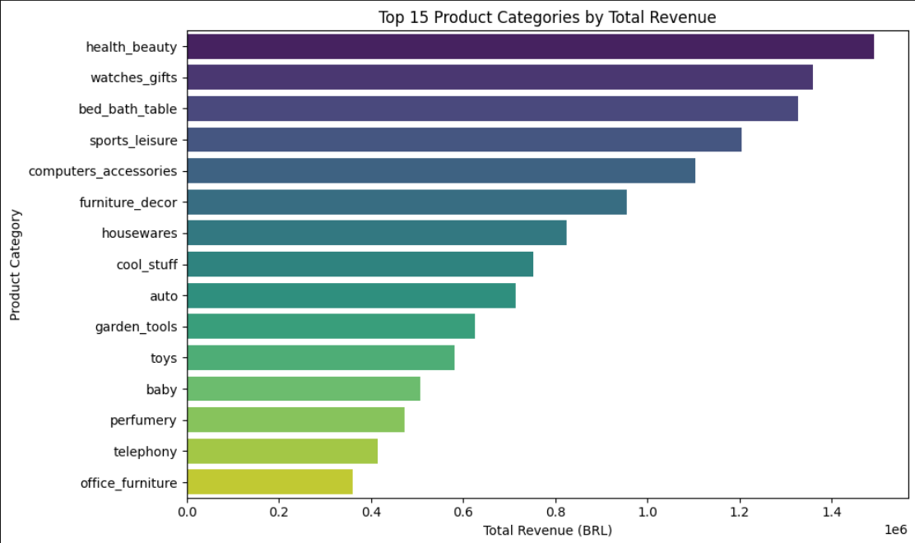
- Figure 3: Customer Retention Rate
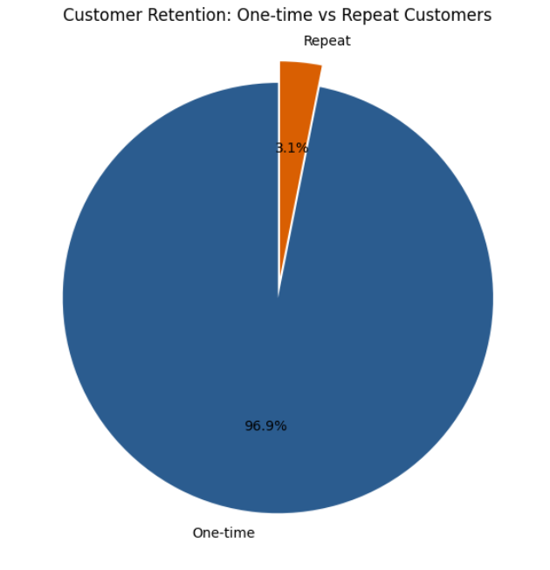

Final Conclusion & Recommendations
The analysis reveals a business model heavily dependent on single-purchase customers and credit card payments. To drive sustainable growth, I recommend:
- 1. Retention Campaigns: Implement loyalty programs or targeted email campaigns to incentivize repeat purchases.
- 2. Logistics Optimization: Invest in regional fulfillment centers to reduce the 12.5-day average delivery lead time.
- 3. Diversification: Promote alternative payment methods like Pix or Boleto to reduce reliance on credit card processing fees.

